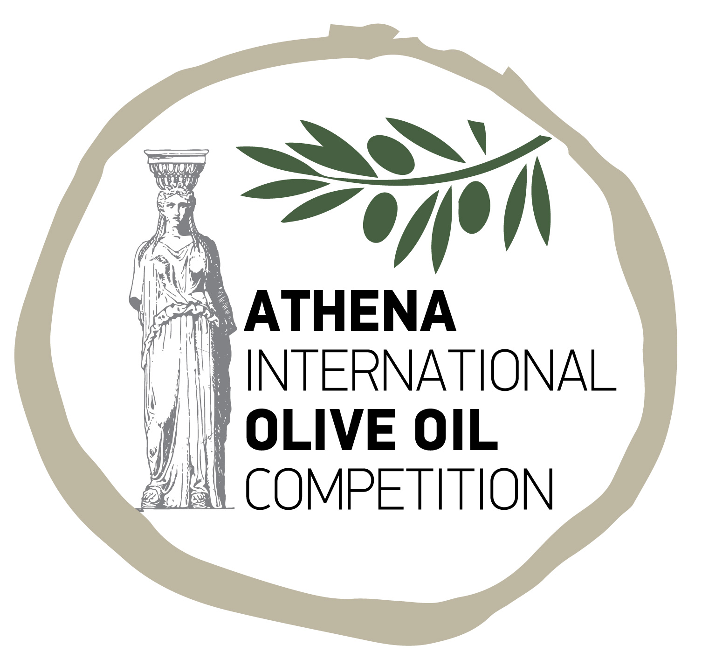

PRESS RELEASE

Athens, January 2019

ATHENA INTERNATIONAL OLIVE OIL COMPETITION 2020

(ΑΤΗΙΟΟC 2020)

2-3-4 April 2020

Lesvos, Greece

The 5th edition of the Αthena International Olive Oil Competition (ATHIOOC 2020) was announced by Vinetum Event Management.

ATHIOOC 2020 will be held 2-3-4 April 2020 on the premises of the Museum of Industrial Olive Oil Production on the island of Lesvos. More than 400 samples of extra virgin olive oils from virtually all countries of the northern hemisphere will be assessed by an international panel of twenty leading olive oil experts, who are opinion leaders in their native lands and the international stage. Previously, ATHIOOC has been organized in Athens, Pylos, Delphi and Nafplion.

Greece, one of the world’s leading olive oil producers and by far the first in terms of per capita consumption, is considered the birthplace of the domesticated olive tree and the country where olive oil became a cultural product and subsequently an internationally recognized component of the Mediterranean diet.

Lesvos was chosen to host this year’s competition as one of Greece’s leading olive oil producing regions, accounting for about 20% of total annual production nationwide. Also, it is home to two exceptional olive tree varietals, kolovi and adramitini.

Competition organizers expect dedicated olive oil producers from around the world to participate at ATHIOOC in the same vein as great actors dream of performing at the ancient theater of Epidaurus or long distance runners aspire to be part of the classic Marathon run; this is a unique opportunity to compete in the land where olive oil was born.

Registration deadline is 16 March 2020. For further information visit our site at www.athenaoliveoil.gr , call us at +30 210 766 0560 or mail us at info@vinetum.gr.

Vinetum Event Management
41 Kareas Ave. GR-16233 Athens | Tel.: +30 210 766 0560 | Email: info@vinetum.gr

